    - Area of a circle
Algorithm
Step 1 :- Start
Step 2 :- Read the radius value from the user.
Step 3:- Set the value of π (pi) as 3.14.
Step 4 :- Calculate area using formula . Area = pi x radius x radius
Step 5 :- Display the area formatted to 4 decimal places.
Step 6 :- Stop
Flowchart
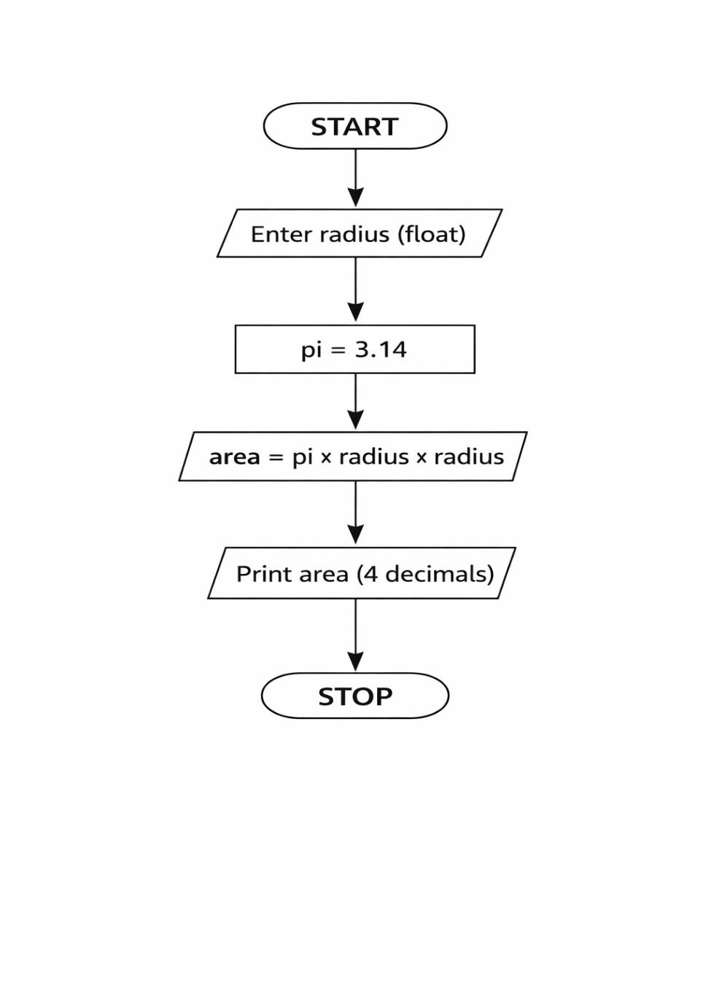
Phyton code
radius = float(input())
pi = 3.14
area = pi * radius * radius
print(f"{area:.4f}")

Execution
